Assignment 1

Alex Thomas

CS396: Principles of Languages

Dr. Eck Doerry

2/22/2016

**Streamroller:**

This function takes in a list. Then the function puts all of the elements in the list to the top level of the list.

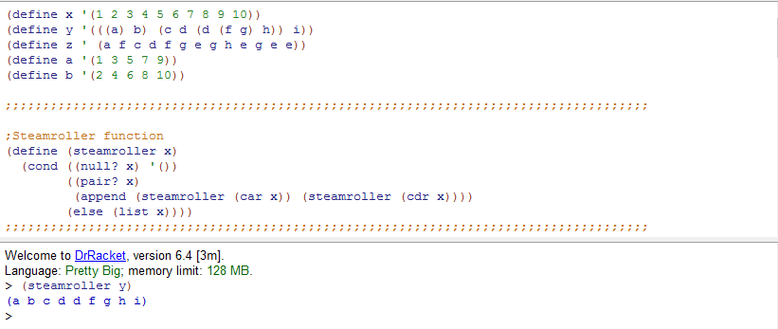

**Ndelete:**

This function takes in a list and a number. Then the function deletes every nth term of the list based on the number entered.

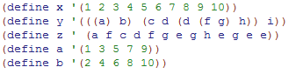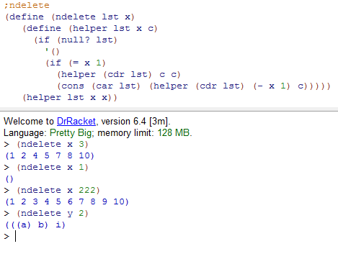

**Deep-member?:**

This takes in an item to search for and a list to search. If the item is in the list it returns true. If the item is not in the list it returns false.

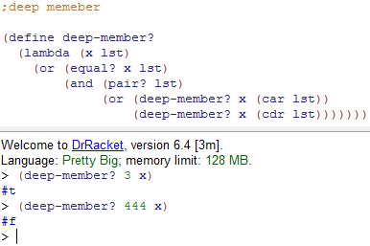

**Splitter problem from assignment:**

This function takes in a list and splits the list. If the list has an odd number of items, it is supposed to put that element in the first list of the two list it creates.

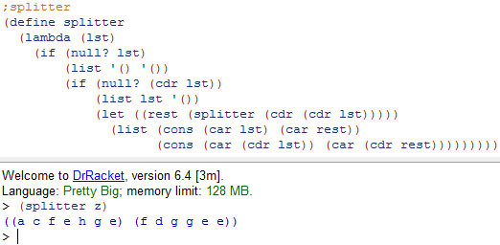

**Merge:**

This function takes in two list and combines them.

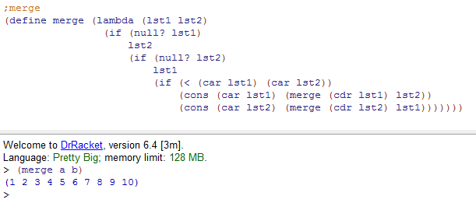

**FN-Maker:**

This function is meant to create functions by passing in a function spec and then formatting it so it is defined like a function. 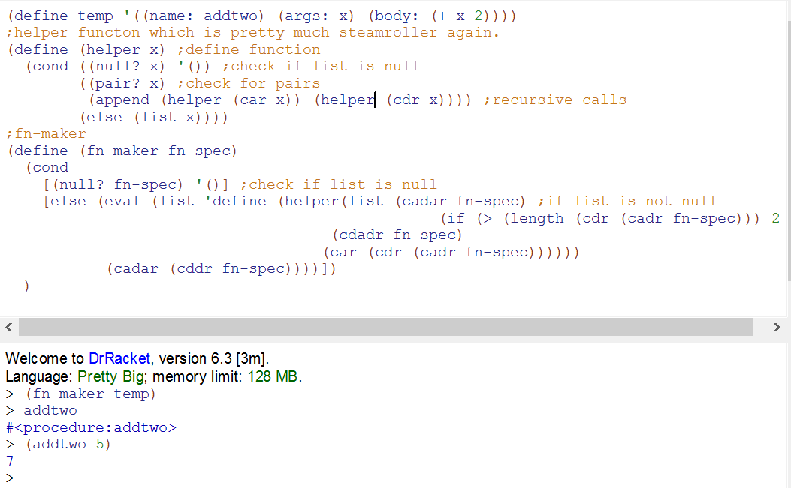

**Markchar (Part of BattleShip):**

This function takes in 2 dimensional coordinates, a character to insert at those coordinates, and a board to apply these changes too. Unfortunately I was unable to figure out how to get this to work. Which means the rest of battle ship could not be finished. If I can figure it out before the deadline for the code, I will mention it in the comments.

Here is my attempt at markchar, check valid to check if the coordinates are in the board. Replace char to replace the character on the board. This is used with getpos to get the position of the char to replace.

